Welcome
We would like to welcome the many new friends we have had this summer as well as our returning friends that spent the summer away. Welcome back everyone!!

Happy Birthday
We would like to wish a very happy birthday to
- Debora G on the 5th
- Bronson L on the 6th
- Emily M on the 11th

Hope you all have a fabulous day!!

Backpacks
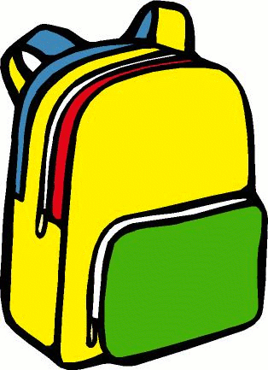
PLEASE bring a backpack to CLC each day
your child comes. It helps store all their
belongings they bring in daily along with any
art work they may make during the day.

School Year Breakfast Times
Just as an FYI, when your child moves over to the school age building, their breakfast time will be from 630-730am each day. If your child will be arriving after 725am, please feed them breakfast at home. Thank you
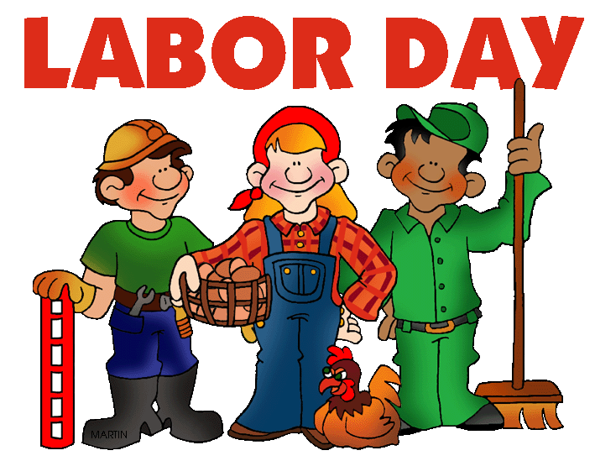
This Photo by Unknown Author is licensed under CC BY-NC-ND
CLC Closed
CLC will be closed Monday, September 5th in observance of Labor Day. If Monday is a regularly scheduled day a vacation day will be posted to your account. Enjoy!!!

Mailboxes for Parents
Your Mailbox slot may be moving. PLEASE make sure you look for your name and check your box daily.

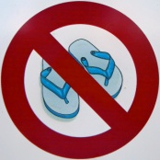
Closed-Toe Shoes
CLC’s policy is that all children and staff wear closed-toe shoes while at CLC. This policy was put into effect for the children’s safety.

SCRIP
Have you ordered your SCRIP gift cards yet? It’s a great way to earn money off your tuition. Talk to Katrina or Lori with any questions.

Amazon Smiles Fundraiser
One way we are able to continue fundraising for CLC is through Amazon Smiles. Simply choose Community Learning

Center as your charitable organization. Each and every order you place through Amazon Smiles benefits CLC. Ask Lori for any questions or to make sure we are receiving the credit through Amazon with Amazon Smiles.

Water Day
SAFFE will be having Water Day each Wednesday, with our final water day being August 24th. Please bring a suit, water shoes and towel on that day. We would also like you to take them home that same day as well so they can be washed and dried. Let’s make an effort to participate this year as we will hopefully have some fun new water day activities planned.

Fall Schedules
With the school year right around the corner, we are
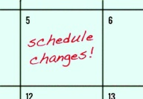
looking at our staffing of the classrooms. We will be handing out paper work for the fall to confirm your child’s schedule. We will also be looking for transportation information along with a few other new school year forms. Please keep an eye on your parent mailboxes for this information. Thanks!!

Culver’s Treat
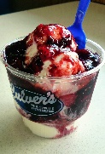
On Tuesday, August 16th, we will be getting a Culver’s custard. We ask families to please bring $4 CASH before this date so we can enjoy the yummy treat. Thanks in advance.
This Photo by Unknown Author is licensed under CC BY-NC-ND

Bake Sale
Saffe will be preparing some yummy snacks the 3rd and 4th week of August and we will be selling them at our annual Bake Sale on August 24th and 25th. We look forward to everyone participating.
This Photo by Unknown Author is licensed under CC BY-NC-ND
End of the Year Pizza Party
Our Bake Sale helps us to fund our delicious end of the year pizza party that will be on the last day of summer at CLC on Wednesday, August 31st. What a fabulous way to kick off back to school!!

Reminder
Just as an FYI, the first day of school for PWSSD is on Thursday, September 1st.

